Computer Networks CL3001 | LAB - 09  Software Defined Networks Lab: Introduction to Mininet
NATIONAL UNIVERSITY OF COMPUTER AND EMERGING SCIENCES, KARACHI CAMPUS
FAST SCHOOL OF COMPUTING (AI & DS, CS, CY, SE)
SPRING 2025

Computer Networks Lab 09

Course: Computer Networks (CL3001) Semester: Spring 2025
Instructor: Muhammad Nadeem T.A: N/A

Note:
- Maintain discipline during the lab.
- Listen and follow the instructions as they are given.
- Just raise hand if you have any problem.
- Completing all tasks of each lab is compulsory.
- Get your lab checked at the end of the session.

Overview

This lab provides an introduction to Mininet, a virtual testbed used for testing network tools and protocols. It demonstrates how to invoke Mininet from the command-line interface (CLI) utility and how to build and emulate topologies using a graphical user interface (GUI) application. In this lab we will use Containernet, a Mininet network emulator fork that allows the use of Docker containers as hosts in emulated network topologies. However, all the concepts covered are bounded to Mininet.

Lab Objective

By the end of this lab, you should be able to:
- Understand Software Defined Networks
- Understand what Mininet is and why it is useful for testing network topologies.
- Invoke Mininet from the CLI.
- Testing Connectivity

- Software Defined Networks:
In conventional networks, the control and management are done locally by dedicated equipment, such as routers and switches. Special algorithms, rules sets and specific hardware (ASICs) are used to perform operations like packet routing and flow forwarding. Configuration is device-centric, and topology changes, require human intervention or long transition phases to come back to normal performance. The lack of flexibility can especially hinder performances in high traffic networks such as Internet Service Providers backbones and within datacenters.

In SDN, the control and data planes are decoupled. The forwarding logic can now be programmed and is not integrated into the hardware as before. The control plane can therefore fully observe the system and sends commands to the elements of the data plane to configure them.

The control plane is composed of one or more controllers. A controller centrally defines the behavior of the network, by computing forwarding rules on request. Switches compose most of the elements of the data plane (along with routers) and are called learning switches

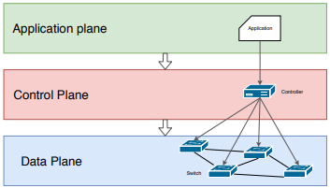
Figure 1: Architecture of Software Defined Networks (SDN)
Lab roadmap

This lab is organized as follows:
- Section 1: Introduction to SDN
- Section 2: Introduction to Mininet.
- Section 3: Invoke Mininet using the CLI.
- Section 4: Testing Connectivity

- Introduction to Mininet
Mininet is a virtual testbed enabling the development and testing of network tools and protocols. With a single command, Mininet can create a realistic virtual network on any type of machine (Virtual Machine (VM), cloud-hosted, or native). Therefore, it provides an inexpensive solution and streamlined development running in line with production networks1. Mininet offers the following features:

- Fast prototyping for new networking protocols.
- Simplified testing for complex topologies without the need of buying expensive hardware.
- Realistic execution as it runs real code on the Unix and Linux kernels.
- Open-source environment backed by a large community contributing extensive documentation.



Mininet Emulated Network Hardware Network
Figure 2 Hardware Network vs Mininet Emulated Network

Mininet is useful for development, teaching, and research as it is easy to customize and interact with it through the CLI or the GUI. Mininet was originally designed to experiment with OpenFlow2 and Software-Defined Networking (SDN)3. This lab, however, only focuses on emulating a simple network environment without SDN-based devices.

Mininet’s logical nodes can be connected into networks. These nodes are sometimes called containers, or more accurately, network namespaces. Containers consume sufficiently fewer resources that networks of over a thousand nodes have created, running on a single laptop. A Mininet container is a process (or group of processes) that no longer has access to all the host system’s native network interfaces. Containers are then assigned virtual Ethernet interfaces, which are connected to other containers through a virtual switch4. Mininet connects a host and a switch using a virtual Ethernet (veth) link. The veth link is analogous to a wire connecting two virtual interfaces, as illustrated below.

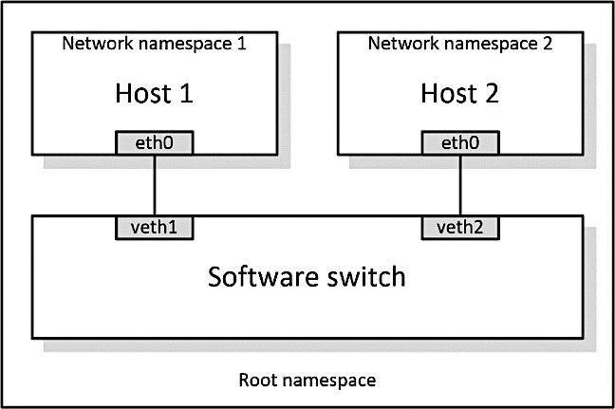
Figure 3 Network namespaces and virtual Ethernet links

Each container is an independent network namespace, a lightweight virtualization feature that provides individual processes with separate network interfaces, routing tables, and Address Resolution Protocol (ARP) tables.

Mininet provides network emulation opposed to simulation, allowing all network software at any layer to be simply run as is; i.e. nodes run the native network software of the physical machine. On the other hand, in a simulated environment applications and protocol implementations need to be ported to run within the simulator before they can be used.

- Invoke Mininet using the CLI
The first step to start Mininet using the CLI is to start a Linux terminal.

  - Invoke Mininet using the default topology

Step 1: Launch the mininet – 2.3.0 in vmware virtual machine and then log-in by by providing username: mininet and password: mininet

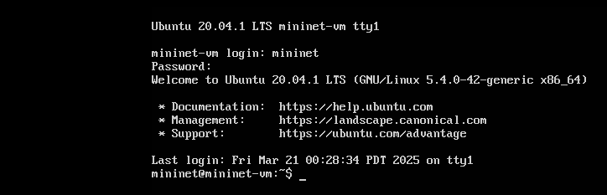

Step 2: To start a minimal topology, enter the command shown below.

sudo mn

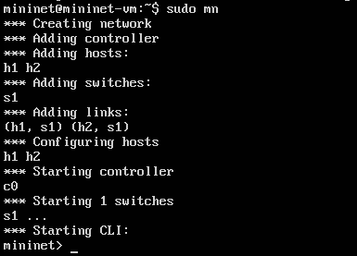
Figure 4 Starting Mininet using CLI
The above command starts Mininet with a minimal topology, which consists of a switch connected to two hosts as shown below. The loaded topology matches the figure below.

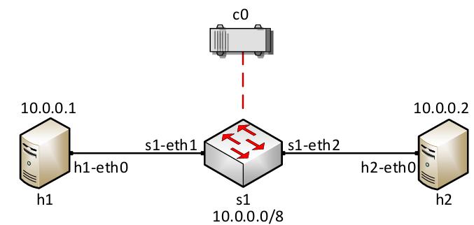
Figure 5 Mininet's default minimal topology
When issuing the sudo mn command, Mininet initializes the topology and launches the mininet command line interface which looks like this:

Step 3: To display the list of Mininet CLI commands and examples on their usage, type the following command.

help

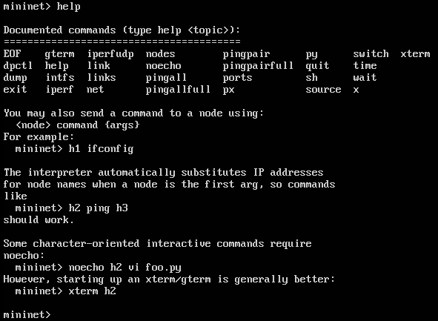
Figure 6 Mininet's help command
Step 4: To display the available nodes, type the following command.

nodes

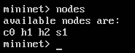
Figure 7Mininet's nodes command
The output of this command shows that there is a controller, two hosts (host h1 and host h2), and a switch (s1).

Step 5: It is useful sometimes to display the links between the devices in Mininet to understand the topology. Issue the command shown below to see the available links.

net
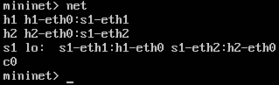
Figure 8Mininet's net command
The output of this command shows that:

1. Host h1 is connected using its network interface h1-eth0 to the switch on interface s1-eth1.
2. Host h2 is connected using its network interface h2-eth0 to the switch on interface s1-eth2.
3. Switch s1:
a. has a loopback interface lo.
b. connects to h1-eth0 through interface s1-eth1.
c. connects to h2-eth0 through interface s1-eth2.
4. Controller c0 is the brain of the network, where it has a global knowledge about the network. A controller instructs the switches on how to forward/drop packets in the network.

Mininet allows you to execute commands on a specific device. To issue a command for a specific node, you must specify the device first, followed by the command.

Step 6: To proceed, issue the following command.

h1 ifconfig

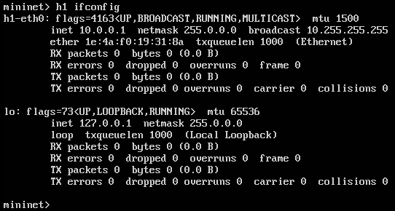
Figure 9 Output of h1 ifconfig command
This command executes the ifconfig Linux command on host h1. The command shows host h1’s interfaces. The display indicates that host h1 has an interface h1-eth0 configured with IP address 10.0.0.1, and another interface lo, configured with IP address 127.0.0.1 (loopback interface).

- Test Connectivity

Mininet’s default topology assigns the IP addresses 10.0.0.1/8 and 10.0.0.2/8 to host h1 and host h2 respectively. To test connectivity between them, you can use the command ping. The ping command operates by sending Internet Control Message Protocol (ICMP) Echo Request messages to the remote computer and waiting for a response or reply. Information available includes how many responses are returned and how long it takes for them to return.

Step 1: On the CLI, type the command shown below. This command tests the connectivity between host h1 and host h2

h1 ping 10.0.0.2
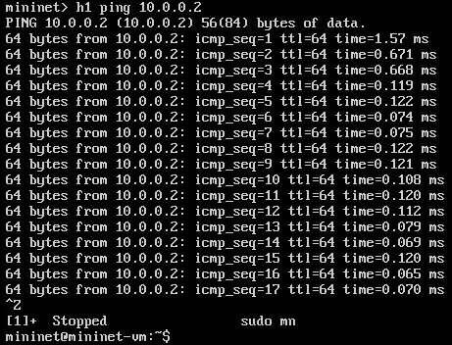
Figure 10 Connectivity test between host h1 and host h2

To stop the test, press ctrl + c. The figure above shows a successful connectivity test. Host h1 (10.0.0.1) sent four packets to host h2 (10.0.0.2) and successfully received the expected responses.

Step 2. Stop the emulation by typing the following command.

exit

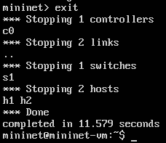
Figure 11 Stopping the emulation using exit
The command sudo mn –c is often used on the Linux terminal (not on the Mininet CLI)
to clean a previous instance of Mininet (e.g., after a crash).

